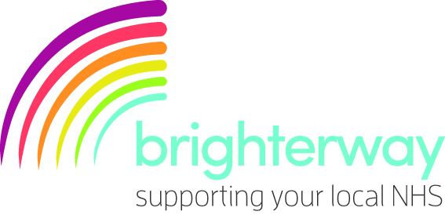
You are invited!
Come along to our fundraising event, taking place from [insert time] on [insert date] at [insert location], to help us raise funds for [insert project name].

The [insert project name] aims to [insert detail]. The project will benefit the people we care for by [insert detail].

Our project and fundraising efforts are supported by brighterway, the charity for Southern Health NHS Foundation Trust. brighterway provides funding and fundraising support for projects which improve people’s quality of life, wellbeing and independence; aid their recovery and prevent them from becoming unwell.

At the event we will have/there will be [insert detail].

We hope to see you there!

Best wishes,
[insert team name]

www.brighterway.org.uk

Copy and paste the table below into your email:

