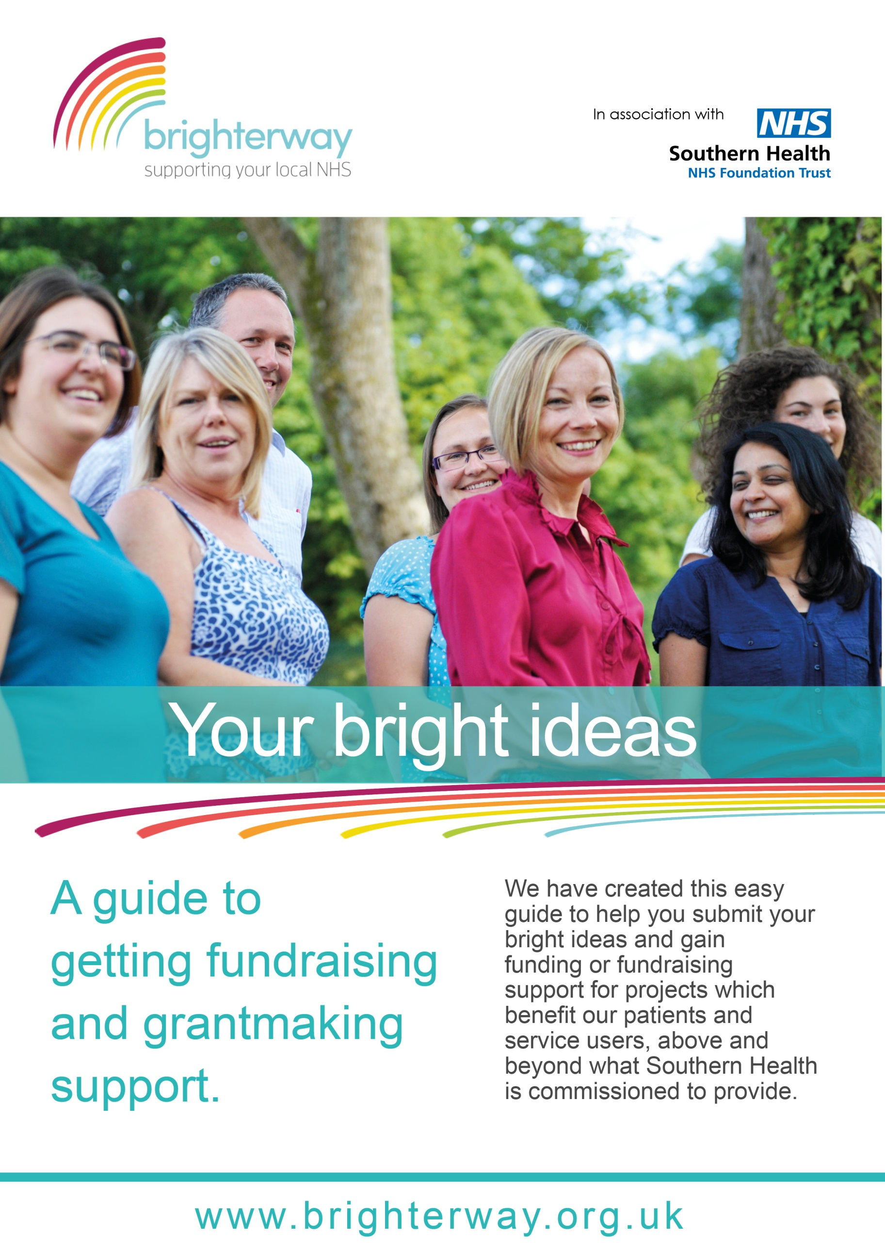
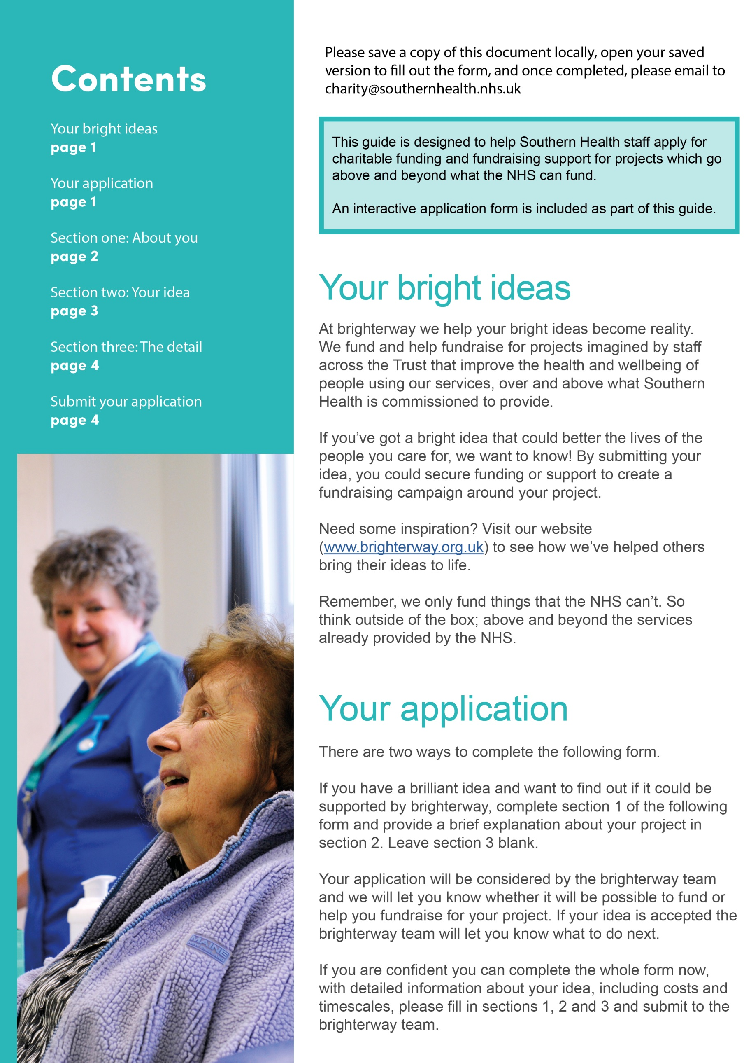
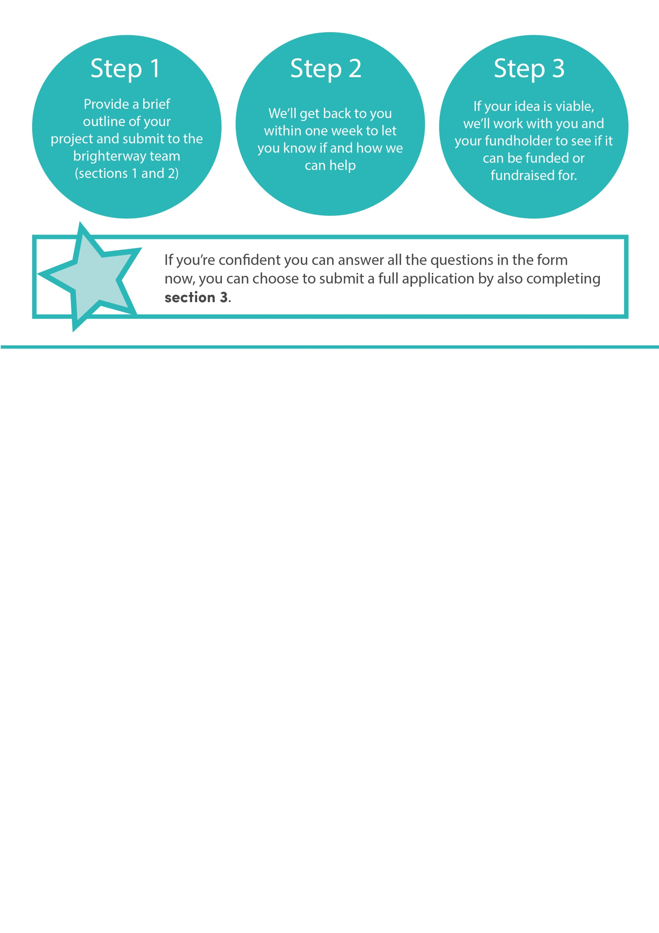
Section 1: About you
Your details…
Name:
Team:
Division:
Email:
My fundholder is…
Name:
Tel:
I want help from brighterway to…
Fundraise for my project: yes/no
Access charitable funds for my project: yes/no
Both: yes/no
I want to…
Provide a brief outline of my idea: yes/no
Submit a full application for charitable funds: yes/no

Section 2: About your idea
What is the name of your project?
…
What is the main difference this project will make?
It will improve people’s experience of an existing NHS service: yes/no
It will improve people’s wellbeing or independence: yes/no
It will improve people’s ability to manage their health condition: yes/no
It will help prevent people from getting ill: yes/no
It will give staff new skills or knowledge to improve quality of care: yes/no
Other (provide details):
What area/s will your project cover:
Andover: yes/no
Basingstoke and surrounds: yes/no
Eastleigh: yes/no
Fareham: yes/no
Gosport: yes/no
Havant: yes/no
New Forest: yes/no
North East Hampshire: yes/no
Romsey: yes/no
Southern Parishes: yes/no
Winchester: yes/no
Trust-wide: yes/no
Describe your project, and which parts of it you need funding for:
...

Why is your project needed, and what will the benefit be to the public?
Tell us about the specific challenges your project will address and the impact it will have
...
Section 3: The details
How did you identify the need and this solution?
…
Who and where are the people who will benefit from your project?
…
Give the names of the services from which your project will be delivered from:
…
When will you project start and end?
Start:
End:
Who will be managing the project?
…
How much will the project cost?
Item/activity | Full cost | Amount you are asking for from charitable funds
Total:

If you don’t need charitable funding for the entire project, where is the rest of the funding coming from?
Southern Health core funds: yes/no
CCG: yes/no
Another charitable funder: yes/no
Another non-charitable funder: yes/no
Other (provide details):
Will the project continue when the charitable funding comes to an end?
yes/no
If so, how will ongoing costs be funded?
…
Once you have completed your application, please save
locally to your computer and email a copy to
charity@southernhealth.nhs.uk

If you have any problems completing the application form,
please call 023 8087 4670.

